HUMBER BRIDGE

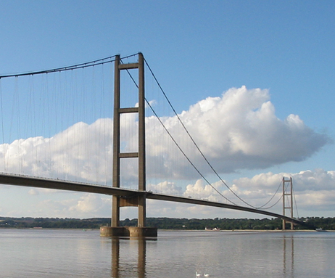
The Humber Bridge, a striking feat of engineering, spans the Humber Estuary in the northeast of England, connecting the East Riding of Yorkshire with North Lincolnshire. It holds the title of being the longest single-span suspension bridge in the world that can be crossed on foot or by bicycle. Constructed between 1972 and 1981, the bridge stretches an impressive length of approximately 2,220 meters (7,280 feet), with a central span of 1,410 meters (4,626 feet). Its iconic design, characterized by two tall towers and sweeping cables, has made it an emblematic landmark of the region.
The origins of the Humber Bridge lie in the mid-20th century when discussions about the necessity of a crossing to alleviate congestion on existing ferry routes and accommodate the increasing traffic flow in the area gained momentum. After several years of planning and feasibility studies, construction commenced, marking the beginning of an ambitious project that would ultimately redefine the region's transportation infrastructure.
The construction of the Humber Bridge was a monumental endeavor, involving innovative engineering techniques and considerable manpower. Its design required meticulous attention to detail, with engineers overcoming numerous challenges posed by the estuary's tidal currents, geological conditions, and environmental considerations. Despite these obstacles, the bridge was completed on schedule and within budget, showcasing the prowess of British engineering on a global scale.

